Phelan Dam Williams Az

“Did you know the Phelan’s built a dam?” I asked my Aunt Emily, their oldest and only living survivor.

“Well I seem to recall something being mentioned way back in the cobwebs of my old brain, but I don’t know the particulars of it.”

“I was doing some research and found these articles on it. He must have been some guy to have all this written on him!”
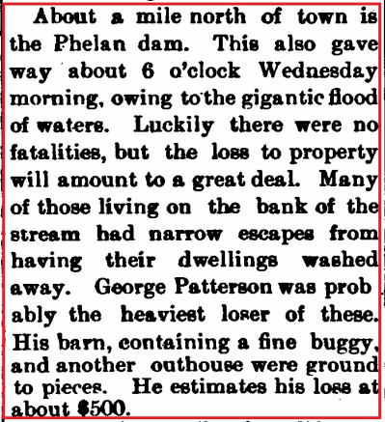
The Phelan dam constructed north of the railroad in Williams around 1896 by J.C. Phelan, held about six million gallons, of which the lumber company used nearly twenty thousand gallons a day. It was claimed that the dam was the main source of Williams's water in 1901, had apparently been leased to the Saginaw and Manistee Lumber Company sometime in 1902 or 1903.

The destruction of the Phelan dam in 1903 had been a result of one of those rare occasions when Williams had more water than she had use for. Intermittent rains and snows in late March 1903, had combined to fill all the dams above town and on March 30, about midnight, their overflow commenced flooding the town. No lives were lost, but the electric plant was submerged, placing the town in total darkness, and the waters carried away fences, sidewalks, and outhouses, and thoroughly soaked a great many more buildings. The chief damage was in the western end of town, although the water reached the main business section and only hasty barricading prevented the water from entering some of the business places. Besides the destruction of the dam, there was some damage to the Caufman structure and a small wooden dam below the main Saginaw dam gave way. This was probably the most extensive flood ever experienced.

Williams News April 4th,1903

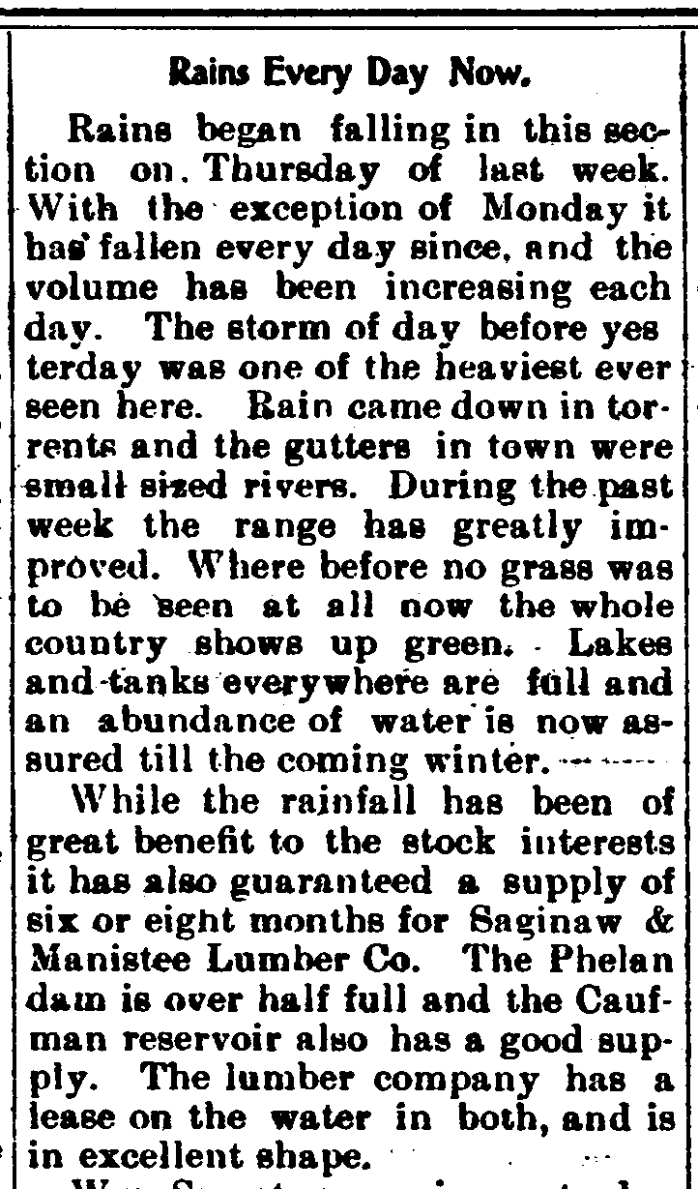
History of Williams, Arizona, 1876-1951 from The U of Arizona

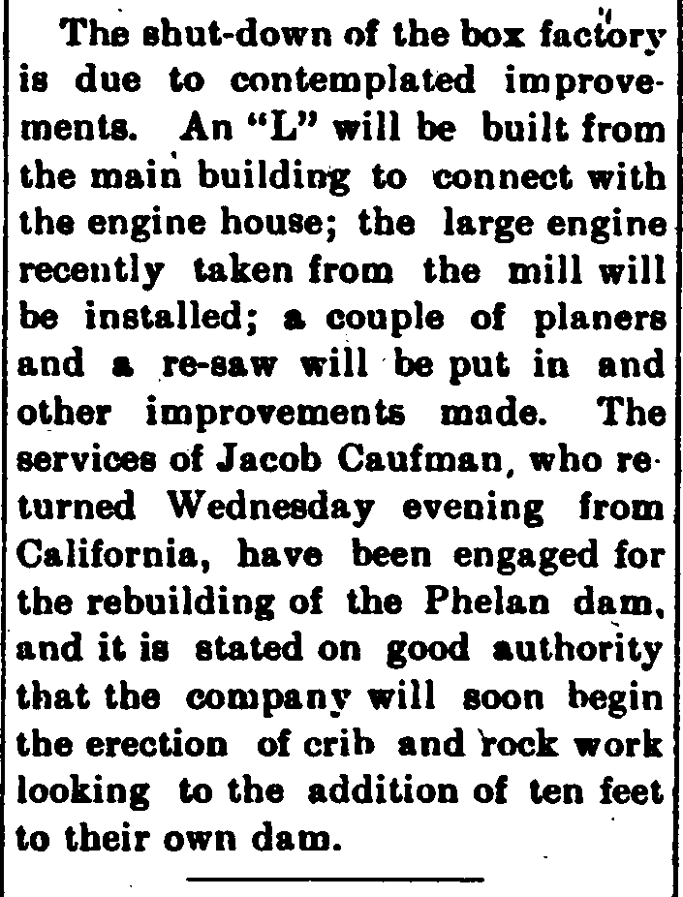

Williams News May 5th, 1906
Williams News July 30th, 1904

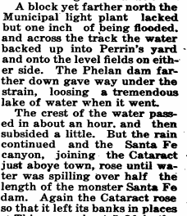

March 14, 1918

Courtesy of Portrait and biographical record of Arizona
J. C. PHELAN - From his earliest recollections Mr. Phelan has been accustomed to the surroundings of mining camps, having followed the fortunes of his parents, who visited different places in search of the hidden treasures of the mines. He was born at Ward, near Boulder, Colo., in 1866, and when a small child was taken to New Mexico, where for several years he lived at different mining camps in the vicinity of Albuquerque. Afterward he became interested in railroading and also learned the butcher's trade in Albuquerque, where for several years he was proprietor of the Railroad Avenue meat market.
When Mr. Phelan came to Williams, in 1889, there were barely two hundred people in the town. He anticipated the needs of the future residents in his special line and started a meat market which has increased in proportions until it is now the largest of its kind between Albuquerque and San Bernardino. During the course of a month he handles about seventy head of cattle, one hundred sheep, and ninety hogs, and besides his local and territorial trade makes occasional shipments to California and Mexico.
In 1896 he bought one hundred and twenty acres of land near Williams, upon which he has perfected an excellent system of water supply. A dam built to catch surface water supplies a pond holding six million gallons, out of which he supplies water for the town of Williams. This furnishes the largest water supply in the locality, as the S. & M. Lumber Company uses about twenty thousand gallons a day from this dam.
While the irrigating and stock interests comprise the chief utilities of Mr. Phelan's ranch, general farming is engaged into a limited ex-tent. He is also the owner of a fruit orchard in Fresno county, Cal., where he raises a fine quality of peaches for shipment. His mining interests are located in the Grand Canyon, Verde and Equator regions. At times he has engaged in successful prospecting. From time to time several lots and buildings in Williams have come into his possession, besides the meat market block and his home residence. As one of the most prominent and popular men in his adopted town, Mr. Phelan has naturally devoted considerable attention to politics, and no one has labored more faithfully than he to secure the incorporation of the town.
His sympathies are strongly on the side of the Democratic party. In 1898 he was elected for a term of four years a member of the board of supervisors of Coconino county, and is the present chairman thereof. During its administration of the affairs of the county, the board has accomplished most gratifying results and has raised its financial standing from forty cents on the dollar to par value. This is but one of the many excellent results that have materialized under the able leadership of Mr. Phelan. Any movement which has tended to improve the general conditions meets his approval and receives his support. No one in the town has a more secure foothold than he upon the esteem of his fellow-townsmen. Fraternally he is associated with the Knights of Pythias and the Woodmen of the World at Williams. By his marriage to Myrtle Dickinson he has two children, Maude and Chris.

"History of Fresno County, California"
by PAUL E. VANDOR
JAMES C. PHELAN The automobile garage owned by James C. Phelan, and named after him, is cleverly planned, well built, and managed according to up-to-date methods. Mr. Phelan's father, who was an honored veteran of the Union Army in our Civil War, is D. F. Phelan, and he is still living at Los Angeles. Prior to casting his lot in the Golden State, he was a pioneer in Colorado. Mrs. Phelan, who was Annie Donahue before her marriage, is deceased. Born in the Centennial State on October 25, 1867, James C. Phelan was educated at the public schools in Colorado and New Mexico, and also, as he likes to put it, in " the great school of experience." As a young man, he ventured in both the grocery and butcher business, having a store when only nineteen years of age, at Albuquerque, N. M. For fourteen years, too, his business at Williams, Arizona, was one of the most progressive and profitable establishments in that town. On September 9, 1893, Mr. Phelan was married to Miss Myrtie Dickinson, and this union was blessed with three boys and four girls, viz : Mary M., Chris E., Roy N., Jimmie J., Ruth E., Bernice L., and Leoma C, all of whom were educated in the public schools of Fresno, the two eldest studied at Heald's Business College, while Roy N., is a student at the University of California at Berkeley. Mr. Phelan has accepted the doctrines of the Christian Scientists, socially he finds recreation in the circles of the Woodmen of the World, the Knights of Pythias, and the Young Men's Christian Association. In May, 1916, he built the finest and most complete auto establishment in California, spending $90,000 upon the same. He then became agent, for the San Joaquin Valley, of the Maxwell, Mitchell and Marmon automobiles, and the Kleiber and Maxwell Trucks. He employs from forty to fifty men to man the several departments, each of which is complete in itself. When he first came to California, in 1905, he worked for three years on the Fresno ranch ; and then, getting into the automobile business in a modest way, he has made success after success. Mr. Phelan sold out in August. 1919. Mr. Phelan is a stanch Democrat, but always something more than a political partisan. In advocating and working for good roads, for example, his public-spiritedness has been particularly shown.

